

**Batch: B-1 Roll No.: 16010422234 Name: Chandana Ramesh Galgali**

**Experiment No.: 5**

**Aim:** Design combinational logic circuit using Logic Gates.

**___________________________________________________________________________**

**Resources needed:** Simulation Platform

**Theory:**

**What is a Combinational Logic Circuit?**

**Ans:** A combinational logic circuit is a type of digital circuit that produces an output based solely on the current input values. It doesn't have any memory elements, such as flip-flops or registers, and the output is determined by the combination of inputs at any given moment. Combinational logic circuits are designed using logic gates, such as AND, OR, NOT, XOR, etc., which perform logical operations on the input signals. These circuits are widely used in various digital systems, including computers, calculators, and communication devices, to perform tasks such as arithmetic operations, data processing, and control functions.

**Explain in brief about Multiplexer.**

**Ans:** A multiplexer, often abbreviated as "MUX," is a digital circuit that combines multiple input signals into a single output signal. It is commonly used in digital systems to select one of many input lines and route it to the output line based on a control signal.

A multiplexer has two main components: input lines and control lines. The number of input lines determines the number of possible input signals that can be selected, and the control lines determine which input signal is chosen.

The most common type of multiplexer is the 2-to-1 multiplexer, which has two input lines, one output line, and one control line. The control line, often referred to as the "select" or "data select" line, determines which input signal is passed through to the output. When the control line is low (0), the first input signal is selected, and when the control line is high (1), the second input signal is selected.

Multiplexers can also have more input lines and control lines, allowing for the selection of multiple input signals. For example, a 4-to-1 multiplexer has four input lines, one output line, and two control lines. The control lines determine which input signal is chosen among the four possibilities.

Multiplexers are used in various applications, such as data routing, data selection, and signal transmission. They play a crucial role in digital systems, enabling efficient data manipulation and control.

**Procedure**:

1. Design combinational circuit for a Seat Belt warning system of Car

* for Beeping the alarm under conditions when any person in driver’s and/or Front passenger’s seat is seated, the seat belt is not fastened when the key is inserted.
* Assume suitable data and mention the same.

1. Design the circuit using Multiplexer and simulate the designed circuit.
2. Verify the circuit for the designed truth table using a test bench.
3. Upload the Schematic Diagram generated on Simulation Software as well as Writeup containing Questions asked in writeup, CO and Conclusion.
4. Please note every document uploaded on google classroom should be labelled as Exp_<No>_<RollNo>_<schematic/writeup>.pdf

**___________________________________________________________________________**

**Observations and Results: Observe the output for different input combinations.**

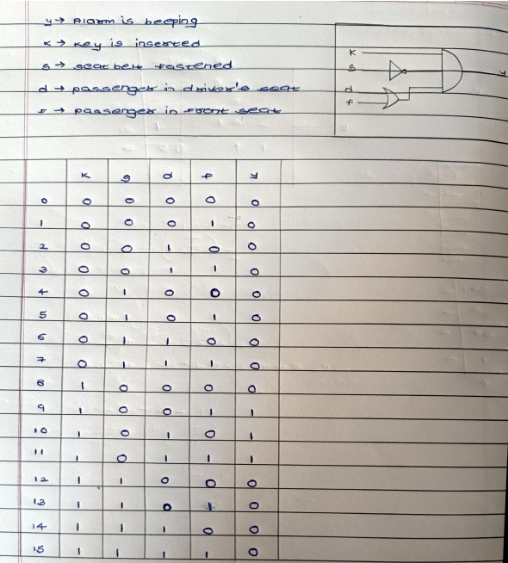

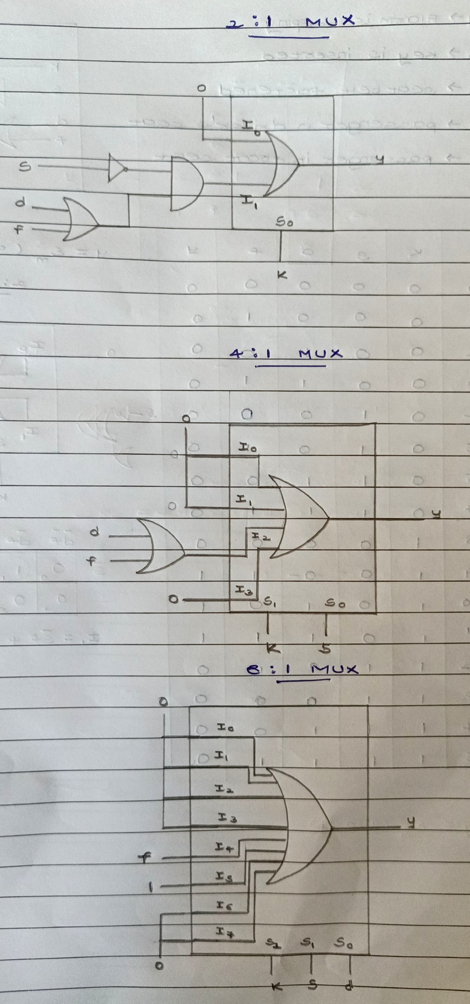

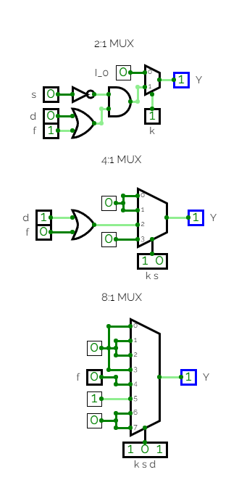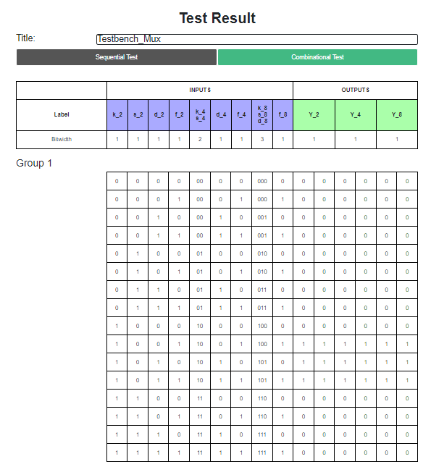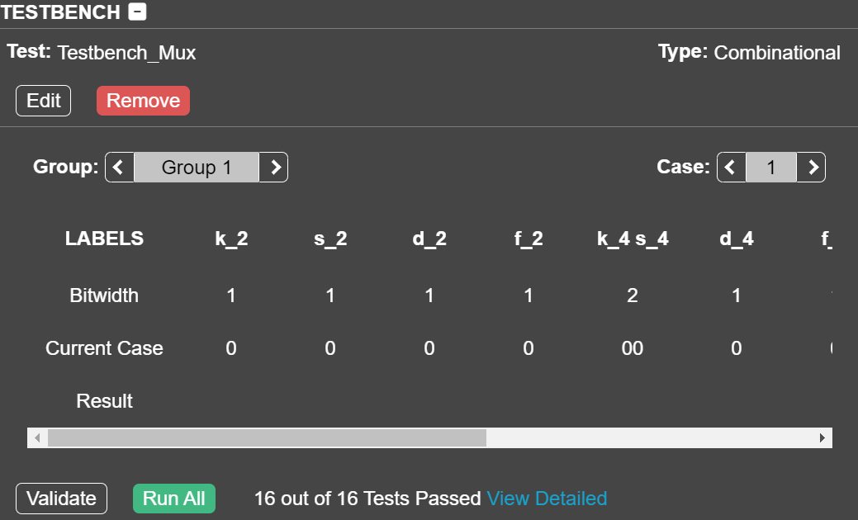

**Outcomes: Understand the basic building blocks, techniques used in digital logic design.**

**___________________________________________________________________________**

**Conclusion:**

We could successfully design a combinational logic circuit using Logic Gates, and also verified it using a test bench.

**Grade: AA / AB / BB / BC / CC / CD /DD**

**Signature of faculty in-charge with date**

**___________________________________________________________________________**

**References:**

**Books/ Journals/ Websites:**

1. Mux simulation- <https://docs.circuitverse.org/#/chapter4/5muxandplex?id=multiplexer>
2. Test bench- <https://docs.circuitverse.org/#/chapter7/3testcircuits>